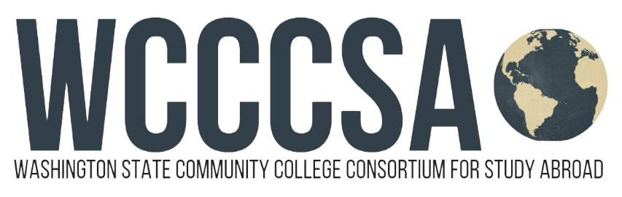

Washington State Community College Consortium for Study Abroad
Budget Request for Study Abroad
Student Name: | Student ID:
Current Email Address: | Have you been accepted into the program yet?  Yes No Not Sure
Program Name: WCCCSA Costa Rica  Program website: www.wcccsa.com/costarica | WCCCSA Program:  2024 Summer/pre-Fall Quarter Costa Rica Program  In partnership with Intercultura Costa Rica Language School

Top of Form
Program Dates:  Start:  8 / 24 / 2024 .  month - day - year  End:  9 / 21 / 2024 .  month - day - year | Circle Term(s) You Will Be Abroad:  Summer or Fall Credit  (determined by student’s institution)  Circle Term(s):  Quarter Semester  Academic Year | OFFICIAL USE ONLY  All boxes have been completed  OIE Staff Initials:  date stamp here

To expedite your request, please provide as much of the following information as possible:
Program Fee: 72-hours Spanish language instruction, 4 weeks accommodation in a local homestay family including breakfasts and dinners, airport transfers to and from San Jose International Airport (SJO), on-site orientations and walking tours, 2 weekend excursions, 1 day excursion, ½ day excursions and group activities, onsite liability insurance and medical insurance. | $3,333.00
Tuition for WA resident students (check with your campus study abroad coordinator) approx. | $675.00
Books & Materials | .00 n
Food: daily lunches, 2-3 dinners when on weekend excursions approx. | $275.00
Roundtrip Airfare approx. | $725.00
Program-related Personal Expenses (telephone SIM card or international plan) approx. | $100.00
Estimated Total | $5108.00

WCCCSA - Study Abroad Campus Coordinator ________________________________________ Date_______________________

