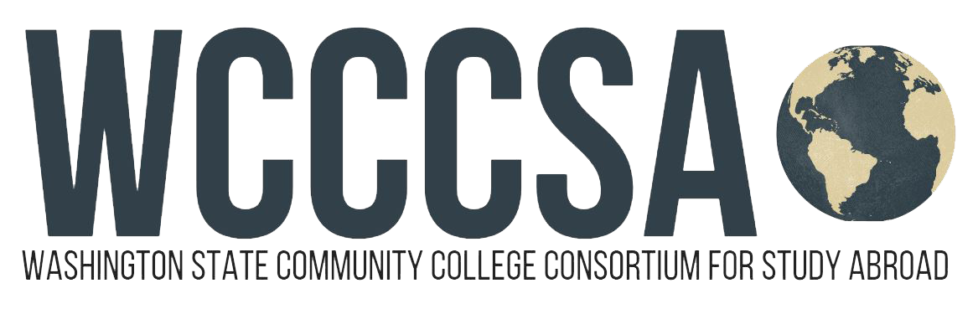

Budget Request for Study Abroad
Student Name: | Student ID:
Current Email Address: | Have you been accepted into the program yet?  Yes No Not Sure
Program Name: WCCCSA  Program website: www.wcccsa.com | WCCCSA Program:  2022 Fall Quarter Barcelona Program  In partnership with Barcelona SAE

Top of Form
Program Dates:  Start:  09 / 26 / 2022 .  month - day - year  End:  12 / 03 / 2022 .  month - day - year | Circle Term(s) You Will Be Abroad:  Summer Fall X Early Fall  Winter Spring  Circle Term(s):  Quarter X Semester  Academic Year | OFFICIAL USE ONLY  All boxes have been completed  OIE Staff Initials:  date stamp here
To expedite your request, please provide as much of the following information as possible:
Program Fee:  Homestay with Breakfast and dinner daily, welcome and farewell lunches, cross-cultural and health/safety orientation, insurance, 24-hour emergency cellphone onsite with SAE staff, cultural program and activities, 1 overnight trip outside of Barcelona, 3 day trips, unlimited 3 month public transportation for zone 1 in Barcelona. |  |  | 6,850.00
Tuition *Varies by college. does not apply for running start students |  |  | 1,450.00
Books & Class Materials |  |  | 80.00 n
Food (lunches & snacks) |  |  | 700.00
Roundtrip Airfare (approx.) |  |  | 1,200.00
Program-related Personal Expenses (phone/data, personal transportation) |  |  | 450.00
Estimated Total |  |  | 10,730.00

Signature of WCCCSA - Study Abroad Campus Coordinator

___________________________________________________________ Date ____________________________

